

EMPLOYEE LEAVE AND PAYROLL MANAGAMENT SYSTEM – Project Team Information

Course: Software Engineering
Instructor: Ms. Rabail Zahid

Submission Date: 28th February 2025

BY:
The Scytes
Ruhab Ahmad (23I-0559)
Hasan Altaf (23I-0698)
Muhammad Saqib (23I-0769)

Team Name
The Scytes

Team Logo
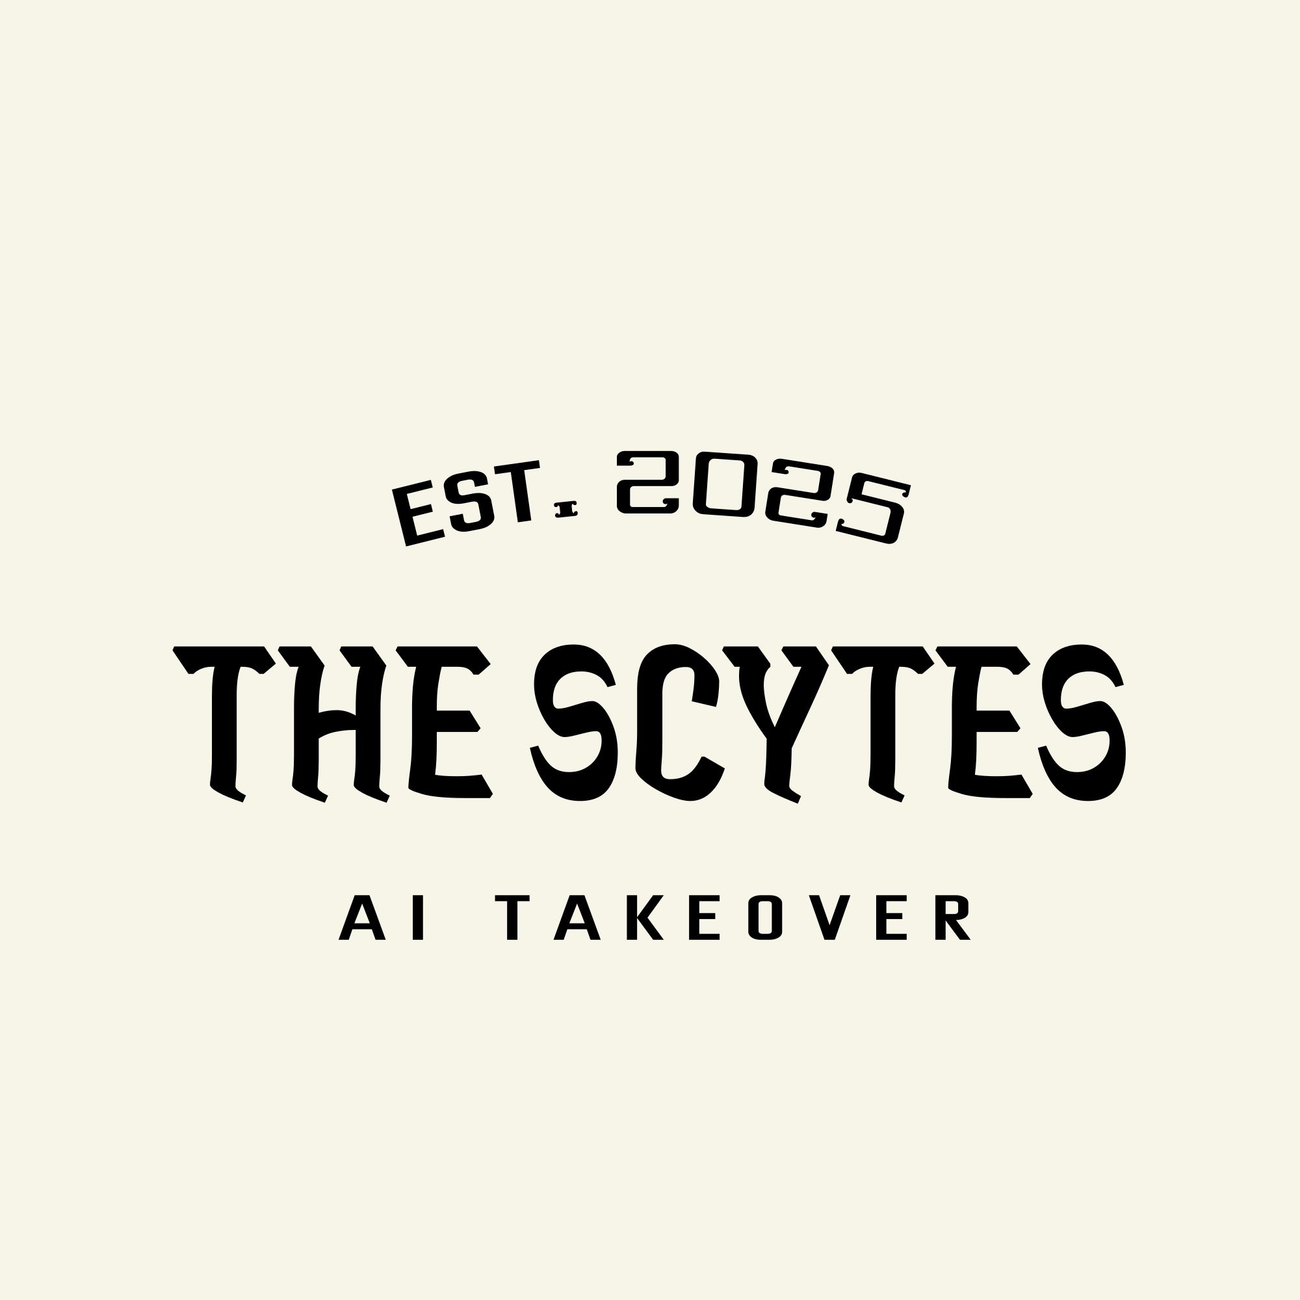

Group Picture
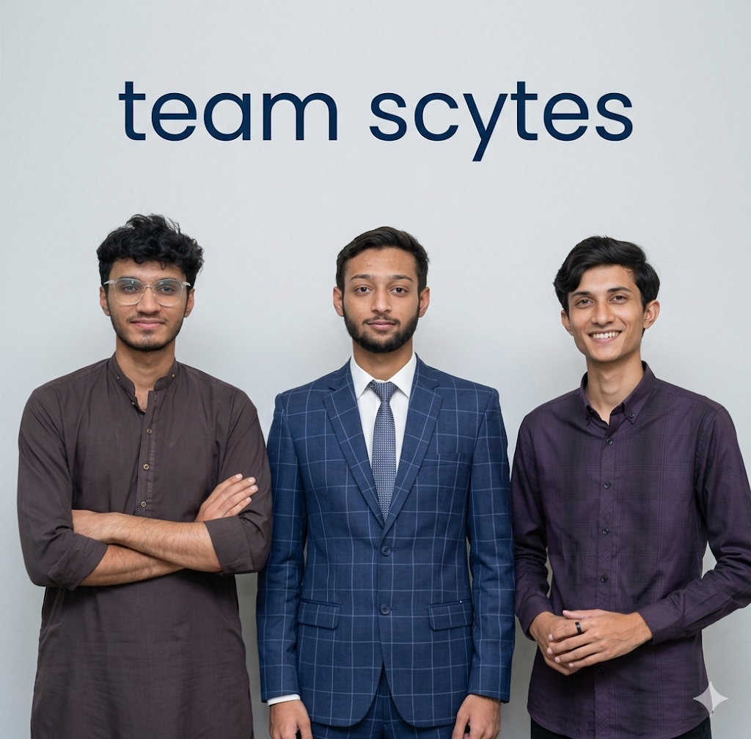

Team Lead
Hasan Altaf (23i-0698)

Team Members

Ruhab Ahmad - Scrum Master & Team Lead
Ruhab - GitHub

I am Ruhab Ahmad, a junior-year Computer Science student at FAST–NUCES, Islamabad. I am a curious and detail-oriented person who is always eager to learn new things. My expertise lies in C++, Python, and full-stack development.

Muhammad Saqib - Developer
Saqib - GitHub

I am Muhammad Saqib Atif, a BSCS student from Batch '23 at FAST NUCES Islamabad. A passionate developer, I aim at improving my skills in web development, AI engineering, and software development to grow as a versatile computer scientist

Hasan Altaf – Developer
Hasan Altaf - GitHub

I am Muhammad Hasan Altaf, a BSCS student from Batch 2023 at FAST NUCES Islamabad, currently in my sixth semester. I am passionate about programming, problem-solving, and building real-world software projects. I continuously work on improving my skills in web development, AI, and data structures to grow as a professional developer.

Assigned Roles
Member | Role
Ruhab Ahmad | Scrum Master, Team Lead
All Members | Testers, Developers
Hasan Altaf | Requirement Analyst
M. Saqib | UI Designer

Team Agreement
Communication Methods
- WhatsApp group for daily communication
- Google Meet for online meetings
- Email for formal communication and submissions
- Trello board for task management, progress tracking, and sprint updates
Response Time
- WhatsApp: within 2 hours
- Email: within 24 hours
- Trello updates: within 24 hours after task progress
- Urgent matters: phone call
Meetings
- Meetings held twice weekly
- All meetings are mandatory
- Meetings conducted online via Google Meet
- Sprint progress reviewed using Trello board
Running Meetings
- Meetings led by Scrum Master
- Meeting agenda shared before each meeting
- Minutes recorded by a rotating team member
- Task status reviewed and updated on Trello
Meeting Preparation
- Members review assigned tasks before meeting
- Prepare progress updates
- Update task status on Trello before meeting
Version Control
- GitHub repository used for code management
- Only working and tested code will be committed
- Commit messages must be clear and descriptive
- Direct changes to main branch are not allowed
- Task progress must match Trello board status
Division of Work
- Tasks assigned by Team Lead
- Work distributed based on skill and availability
- Task responsibilities tracked using Trello
- Stakeholders identified as HR staff, employees, and management
Submission Process
- Work reviewed by all team members
- Final submission handled by Team Lead
- Deliverables submitted one day before deadline
- Completion of tasks verified through Trello board
Contingency Planning
- Missed tasks reassigned to another member
- Repeated absence reported to instructor
- Academic dishonesty results in removal from project
- Incomplete tasks moved to next sprint and marked as leftover on Trello

